JOBSHEET 3

1. 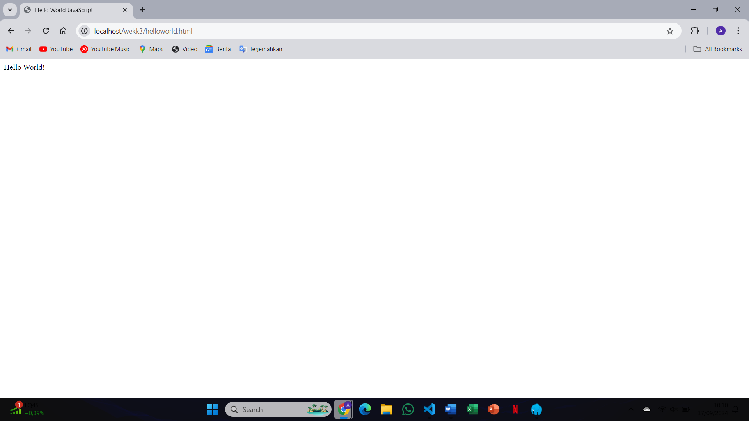The browser will display a pop-up alert with the message "Hello World!" as coded in the <script> tag
2. 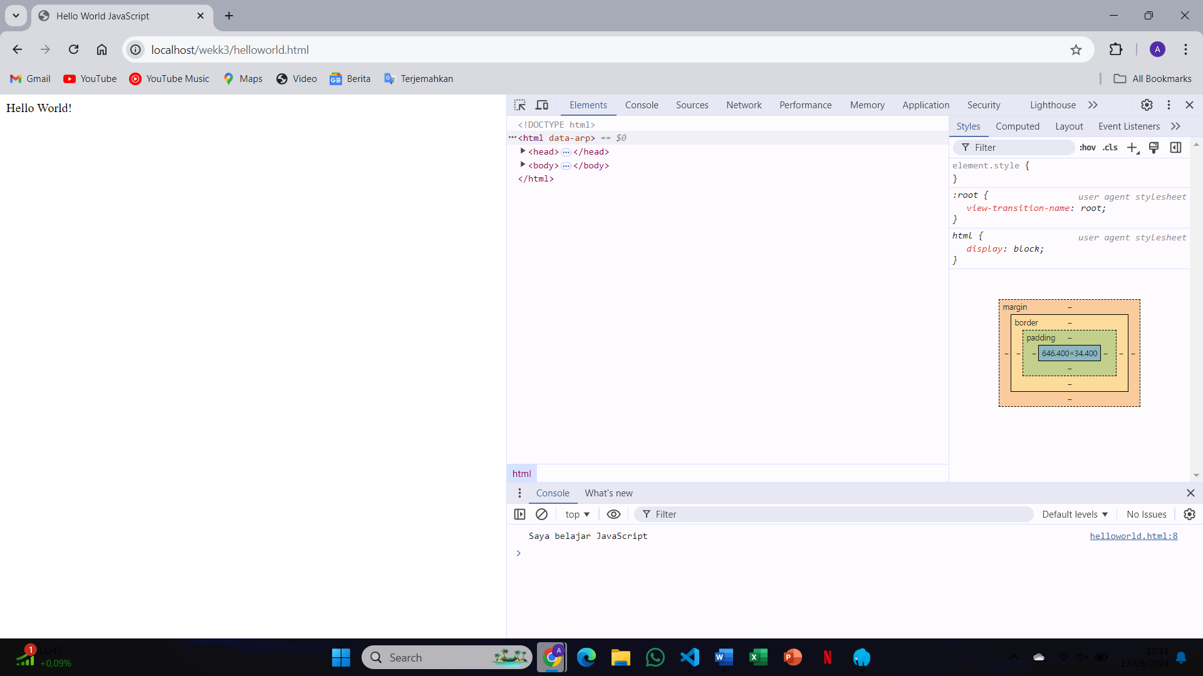The console will show no errors. The alert has already been executed, but no further output is expected unless you log something explicitly to the console
3. The alert() function does not log anything to the console; it only shows a pop-up dialog on the browser
4. 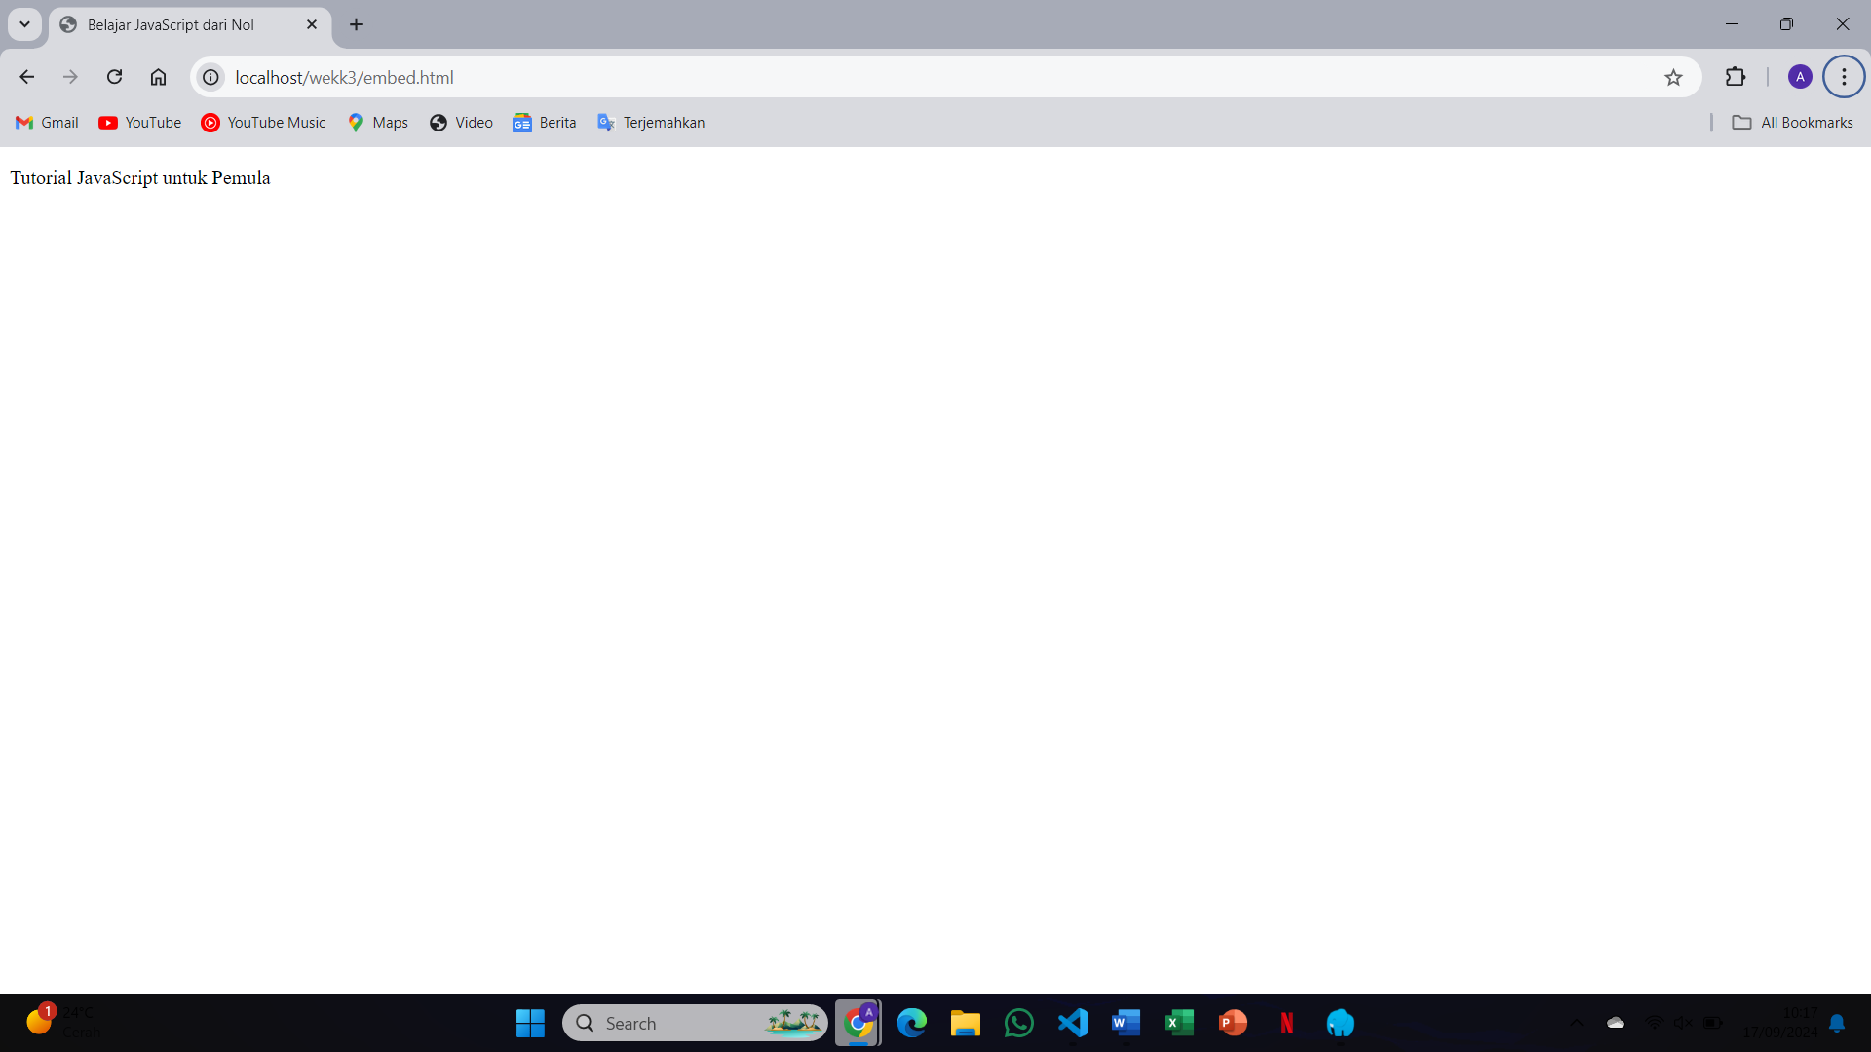The browser displays "Hello, world!" written directly in the HTML body. The embedded JavaScript alters the content within the <body> tag using document.write()
5. It depends. Writing it in the <head> executes the script before the body loads, which can sometimes be a problem if the script interacts with HTML elements. Writing in the <body> tag ensures the HTML is loaded first
6. 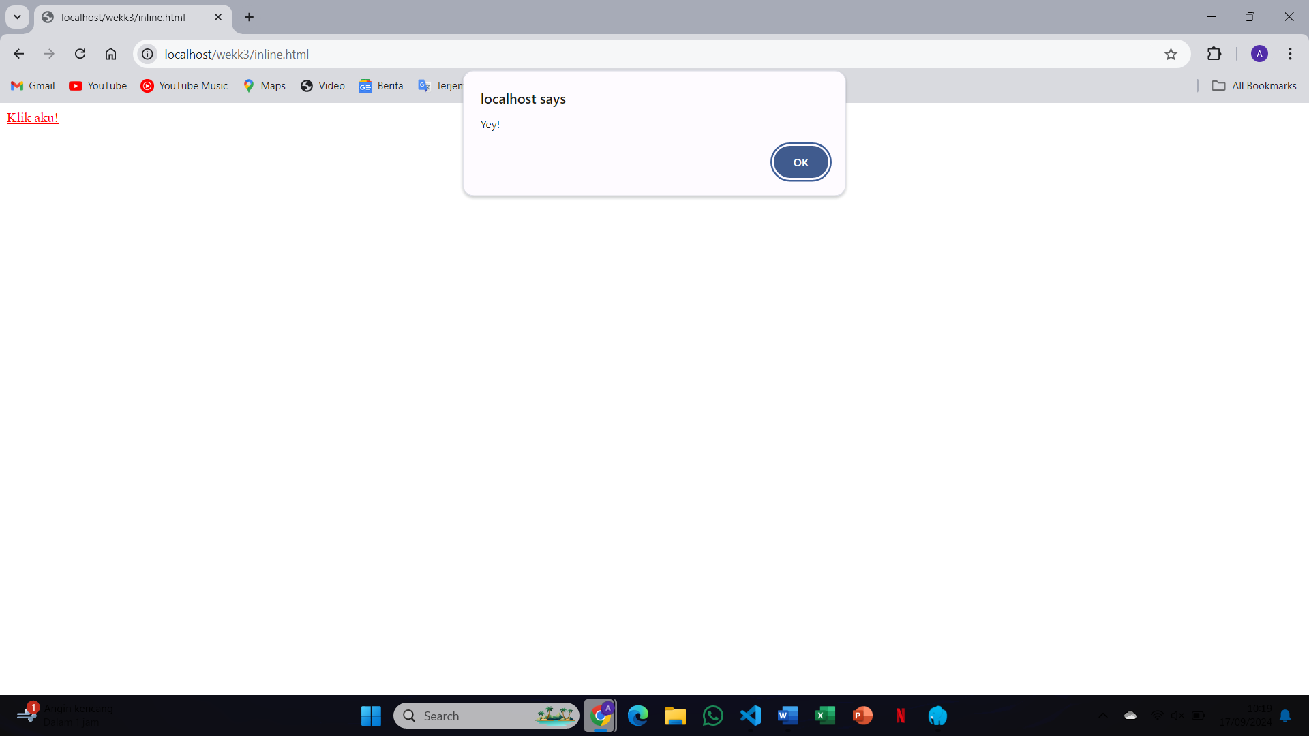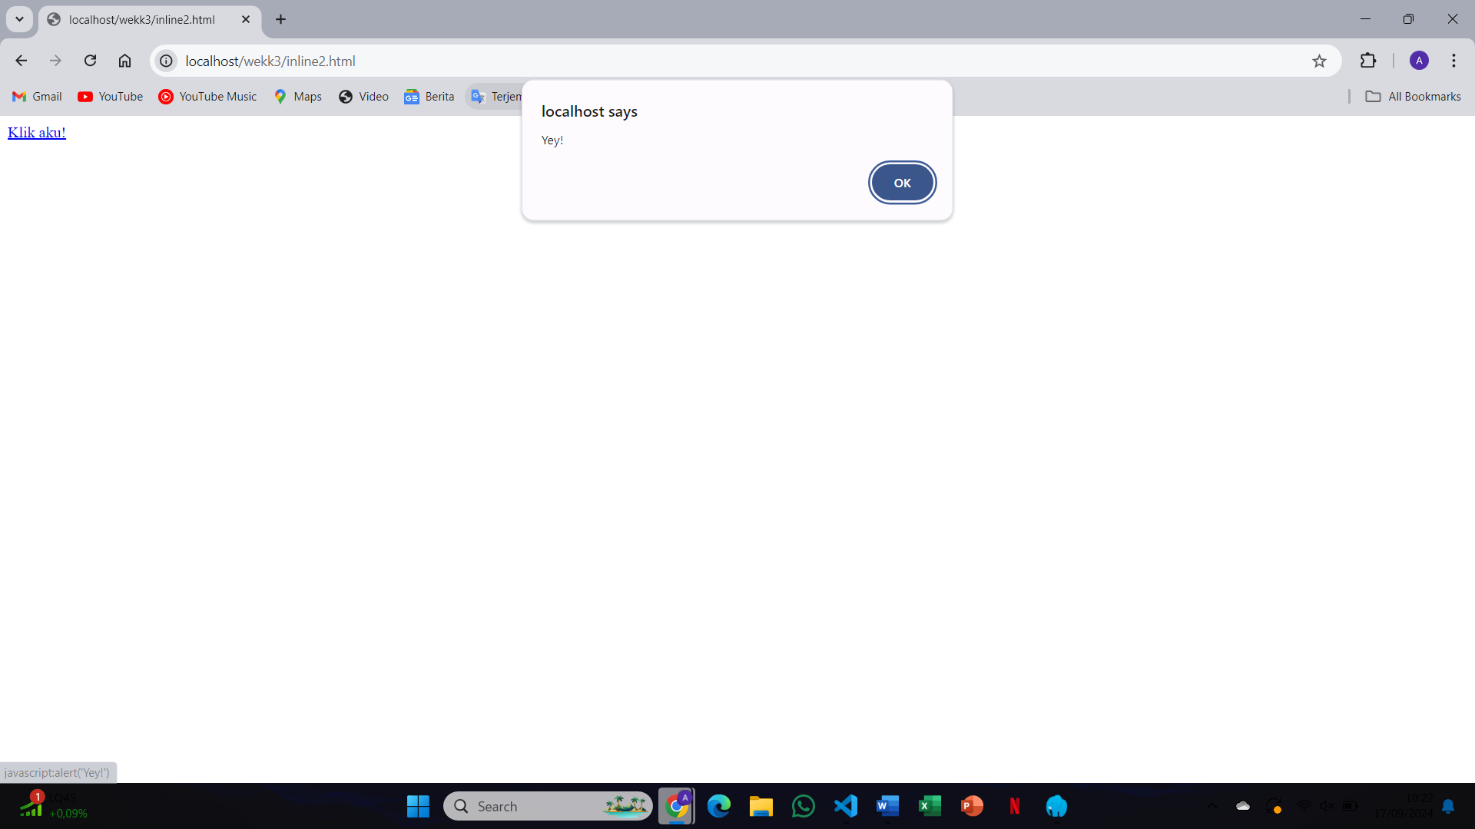Clicking the button triggers a pop-up with the message "You clicked me!" because the JavaScript code is executed inline when the button is clicked
7. The first code has the inline onclick event attached directly to the HTML tag, while the second uses a separate JavaScript function call in the onclick attribute. Both perform the same action but are written differently
8. 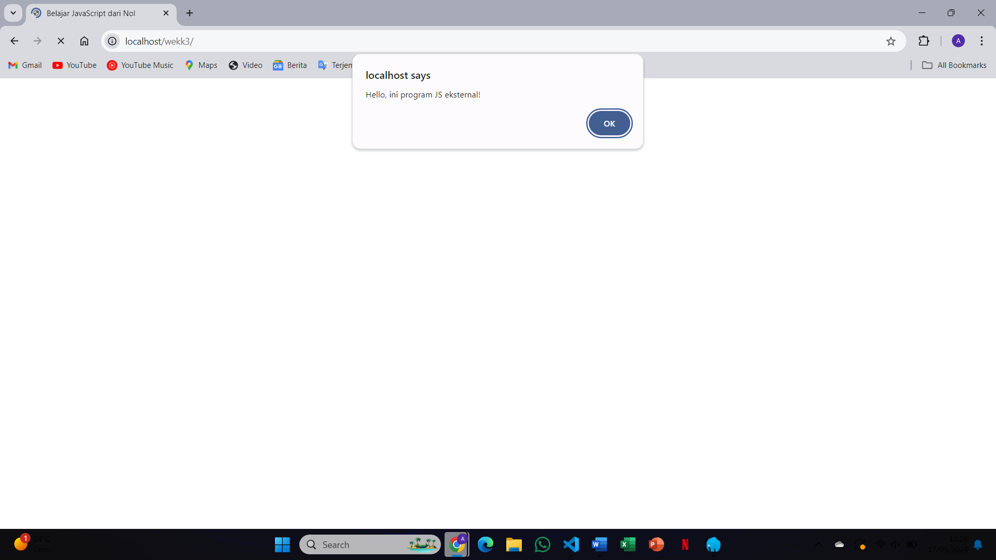The browser displays "Hello from an external file" as the external JavaScript is correctly linked and executed
9. 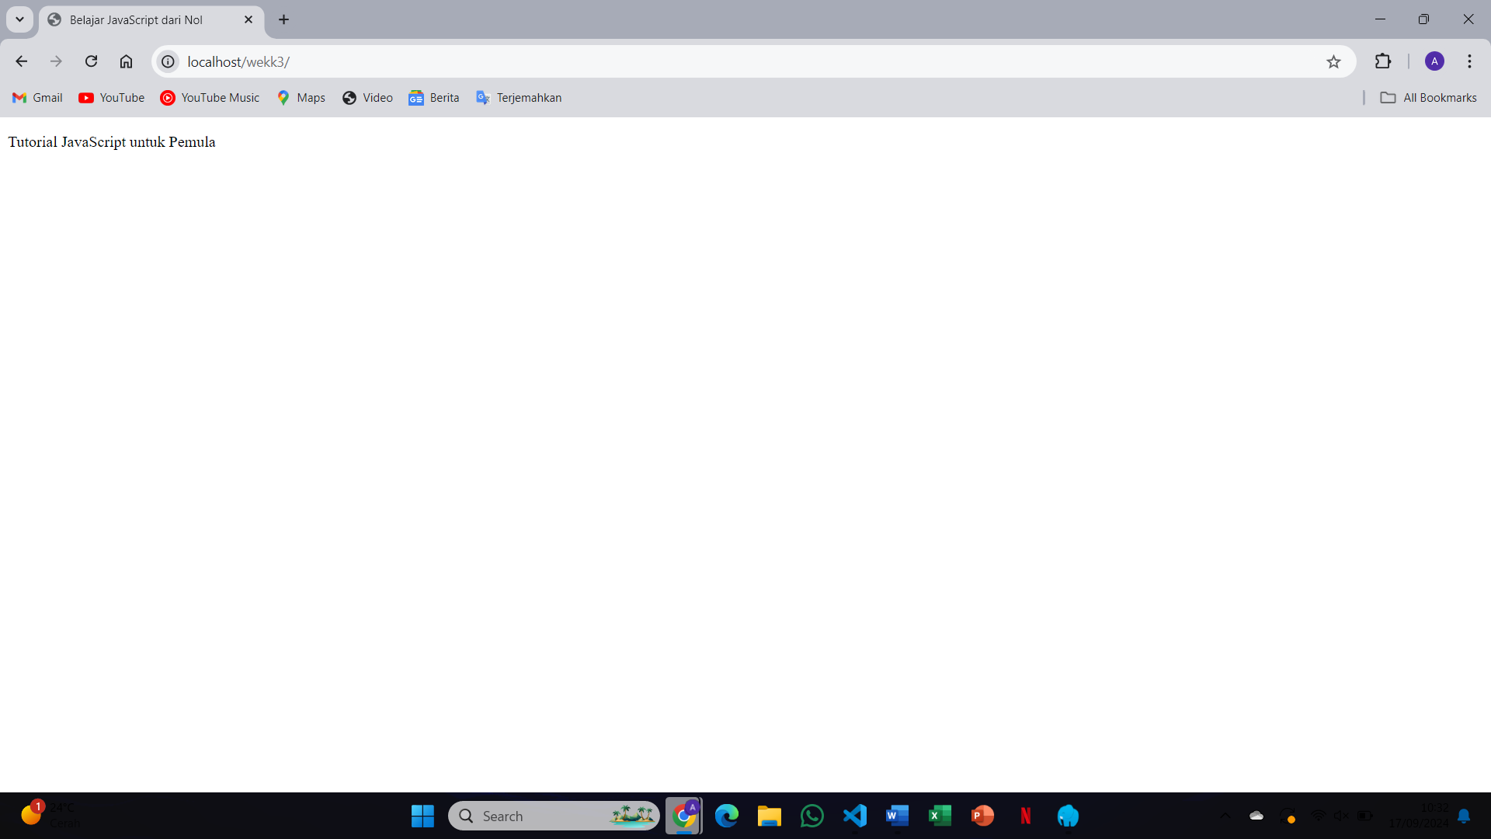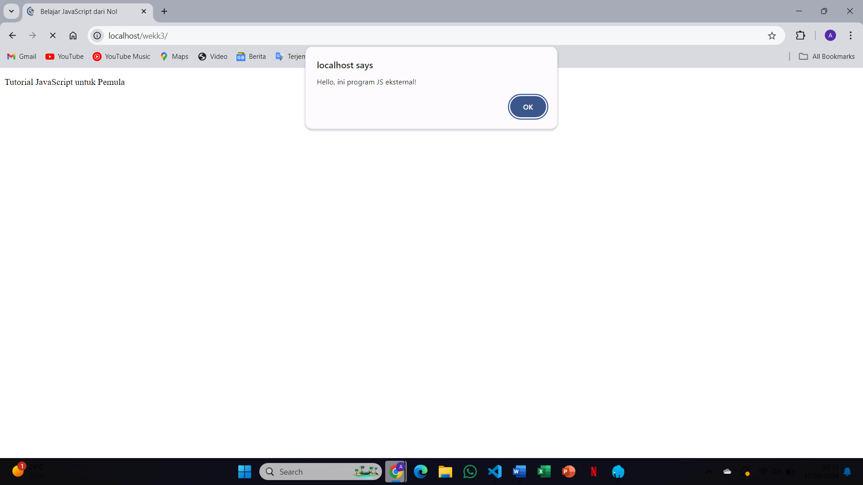If the path to kode-program.js is incorrect, the JavaScript code won't execute, and you'll get a "404 Not Found" error in the console
10. 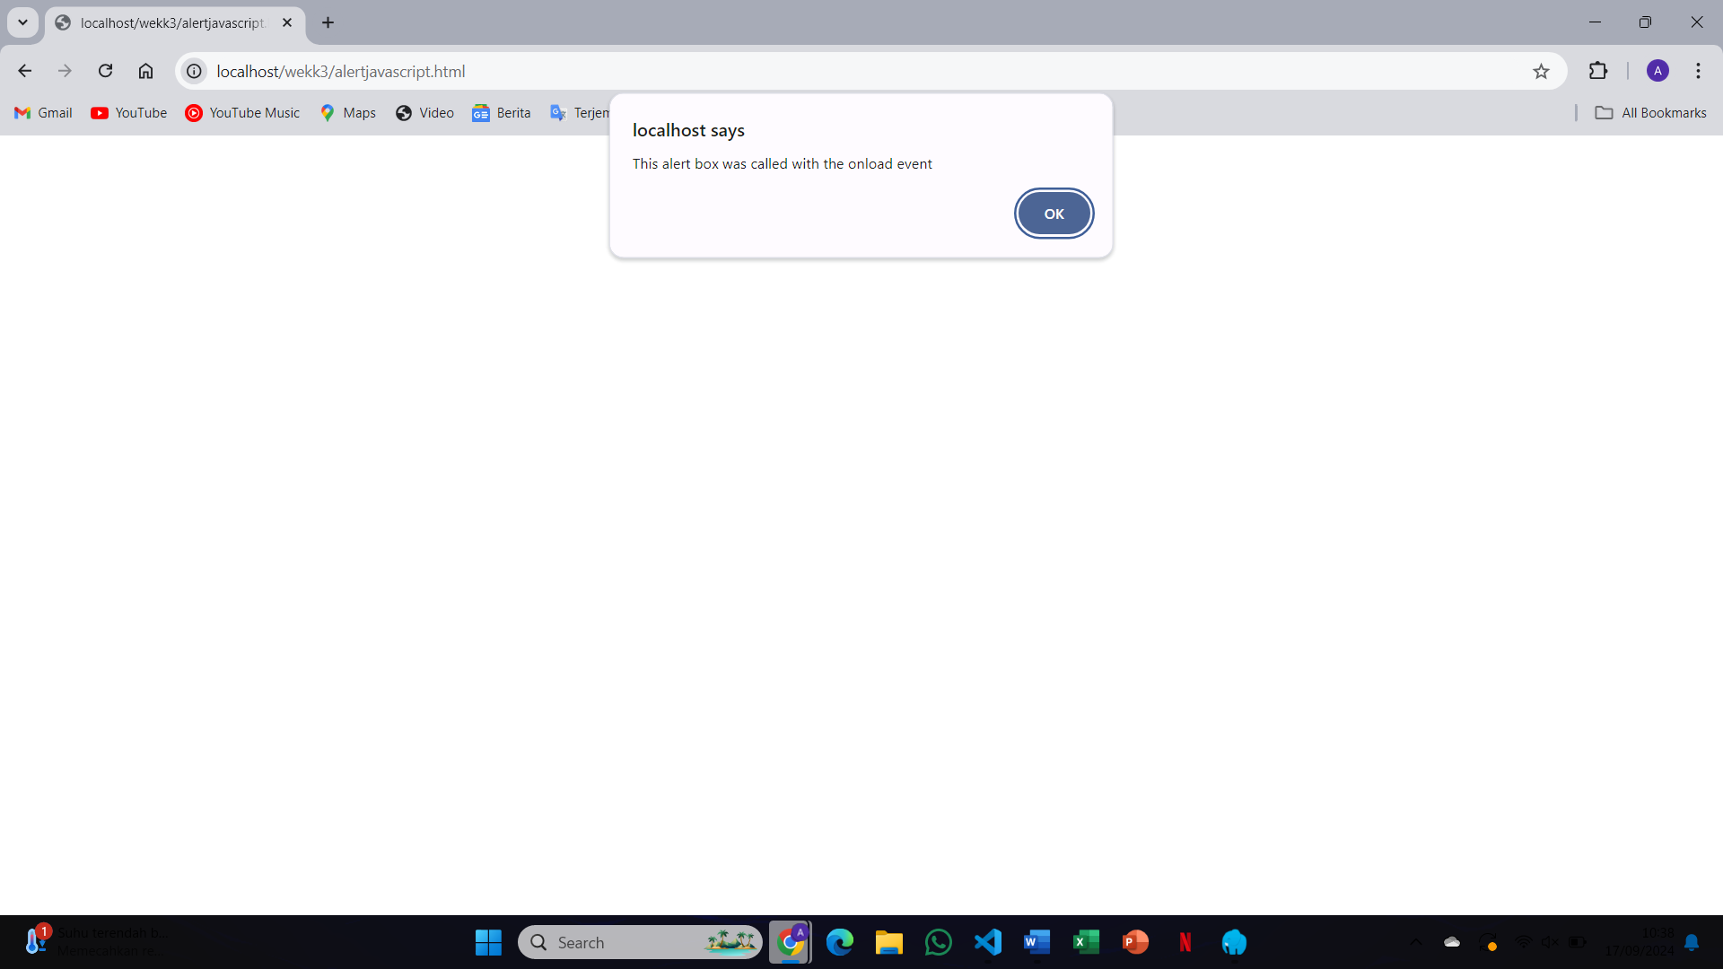 pop-up alert will appear with the message "This is an alert dialog!"
11. 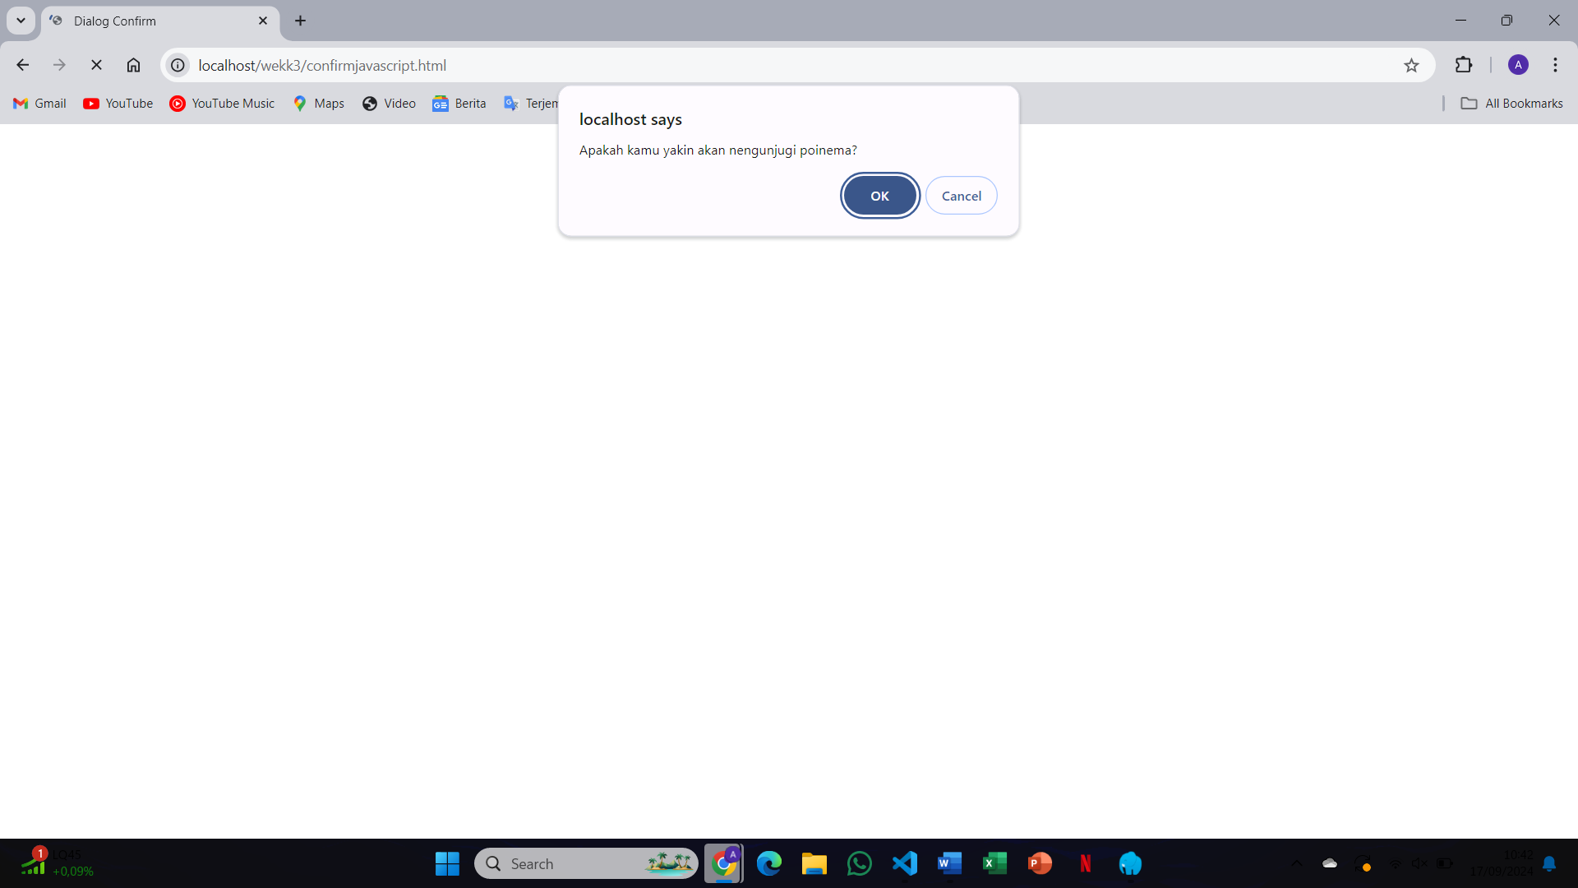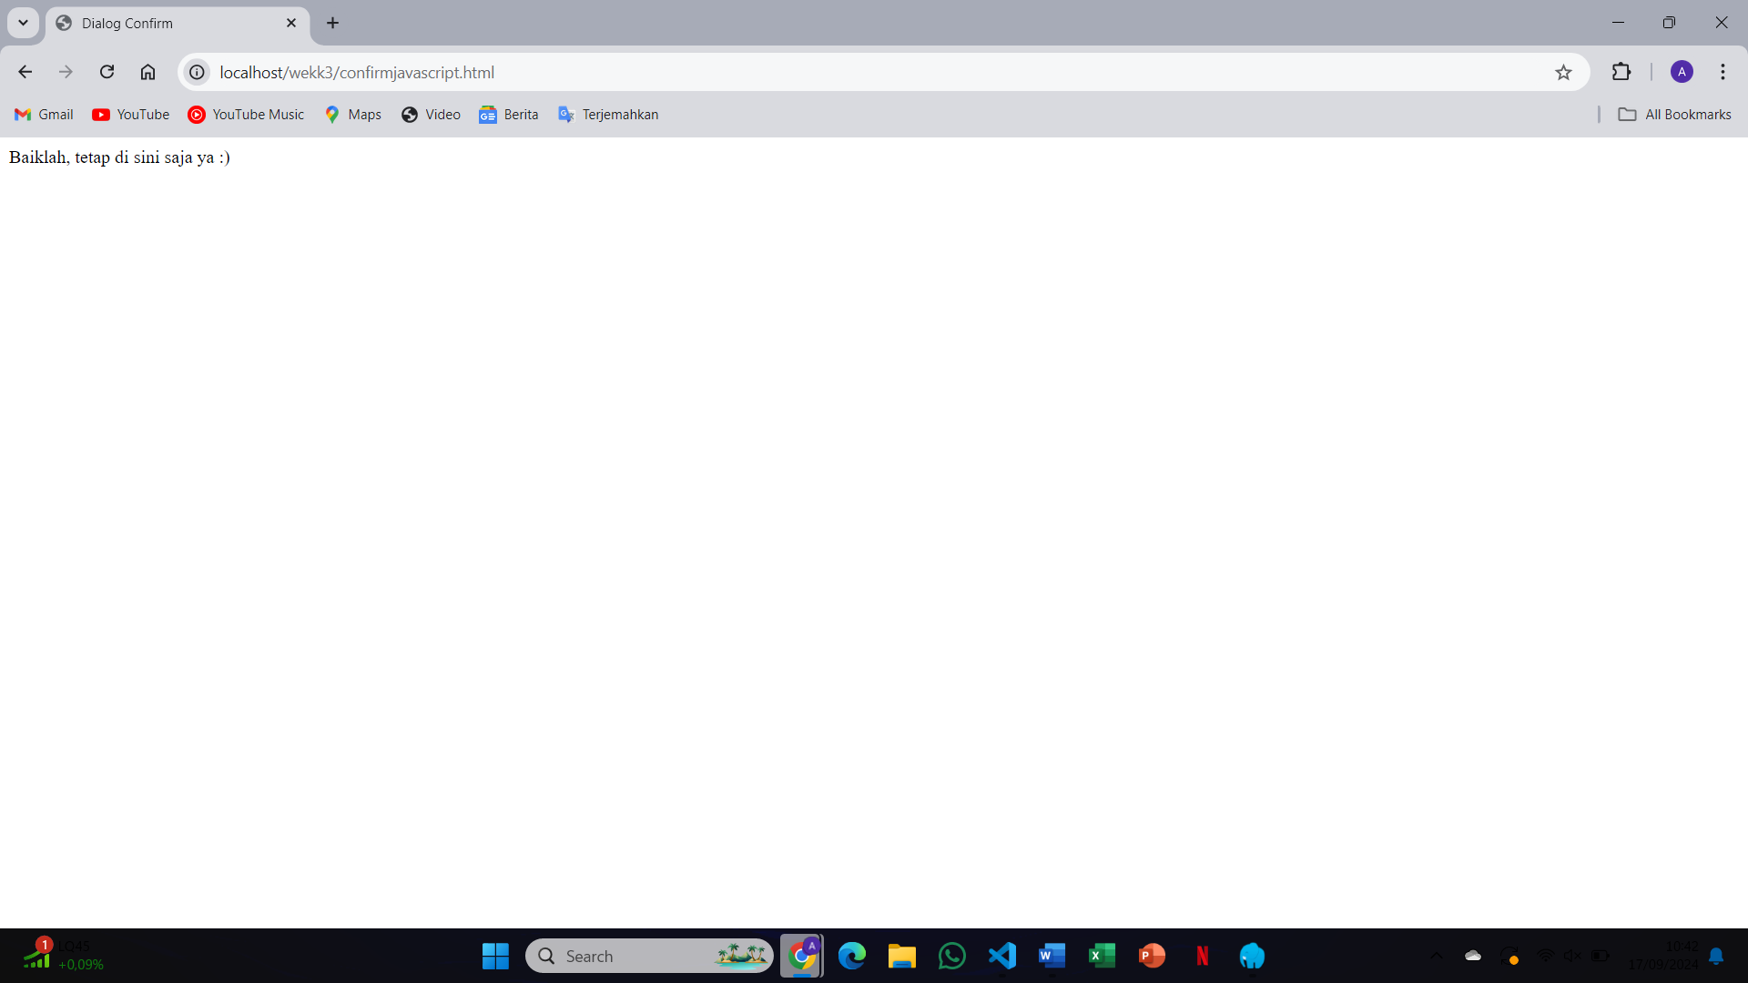A confirmation dialog will appear with "Are you sure?". Clicking "OK" or "Cancel" triggers the respective outcomes
12. 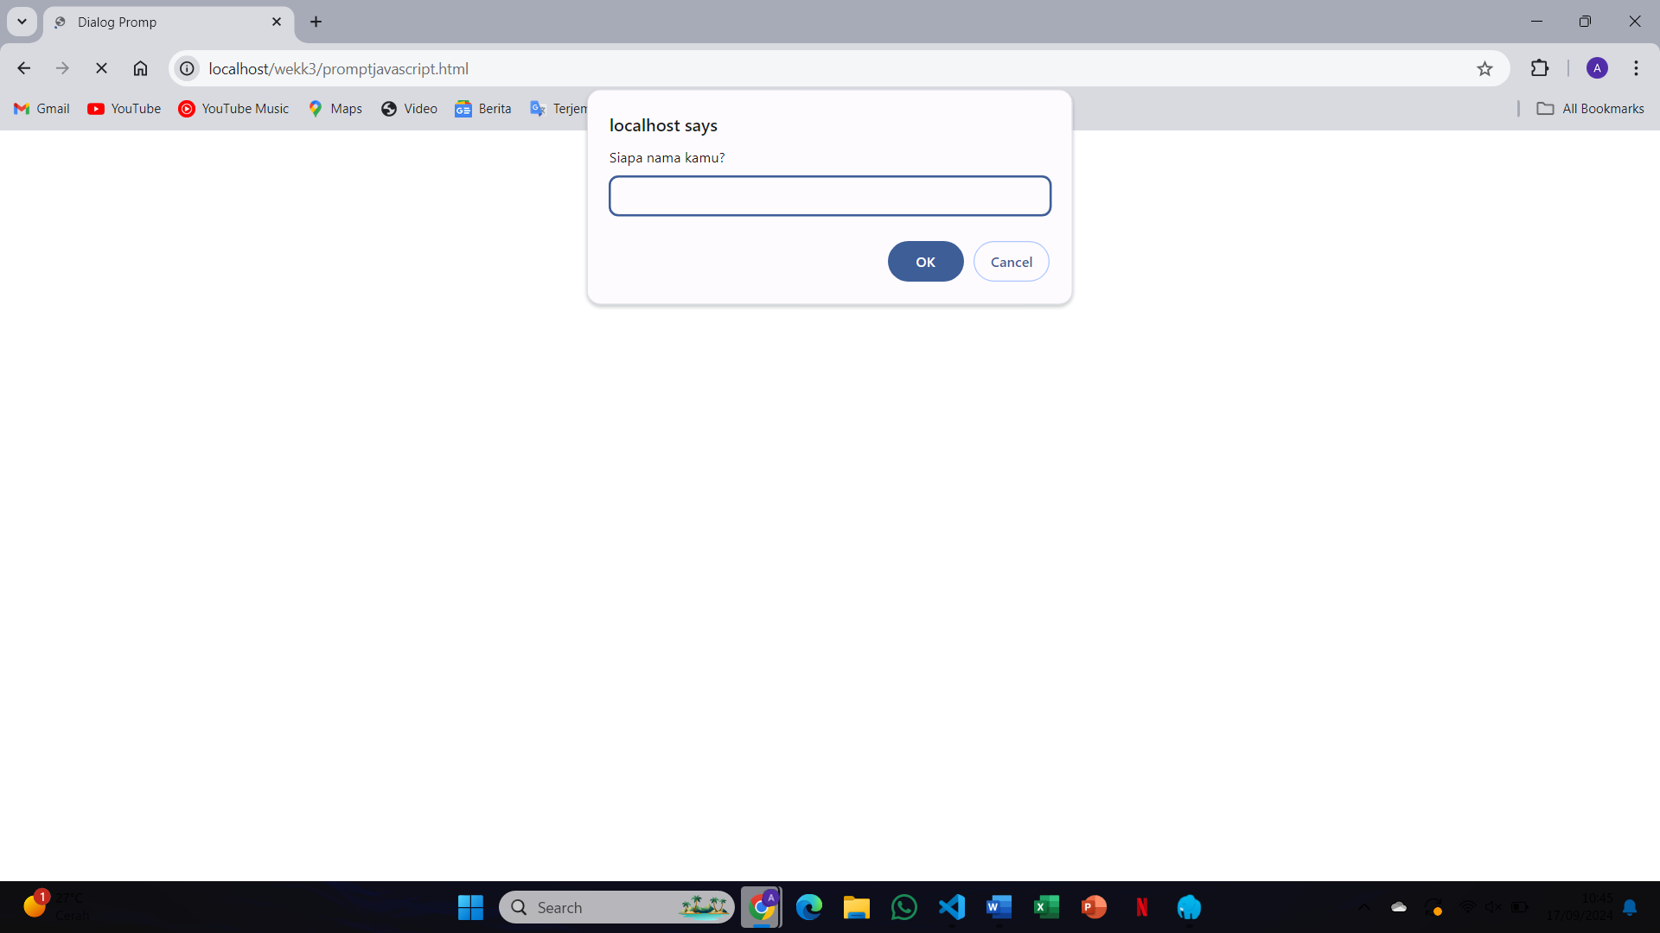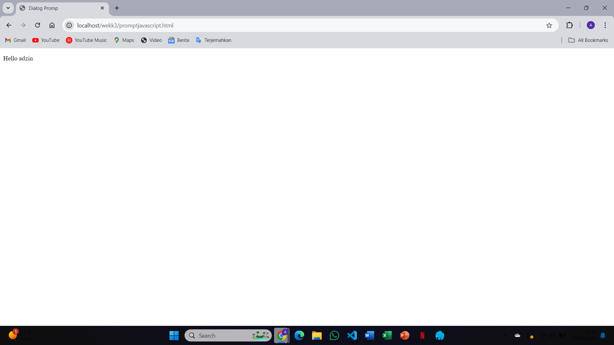A prompt dialog will appear asking the user to enter something. The input will be displayed as the prompt value
13. 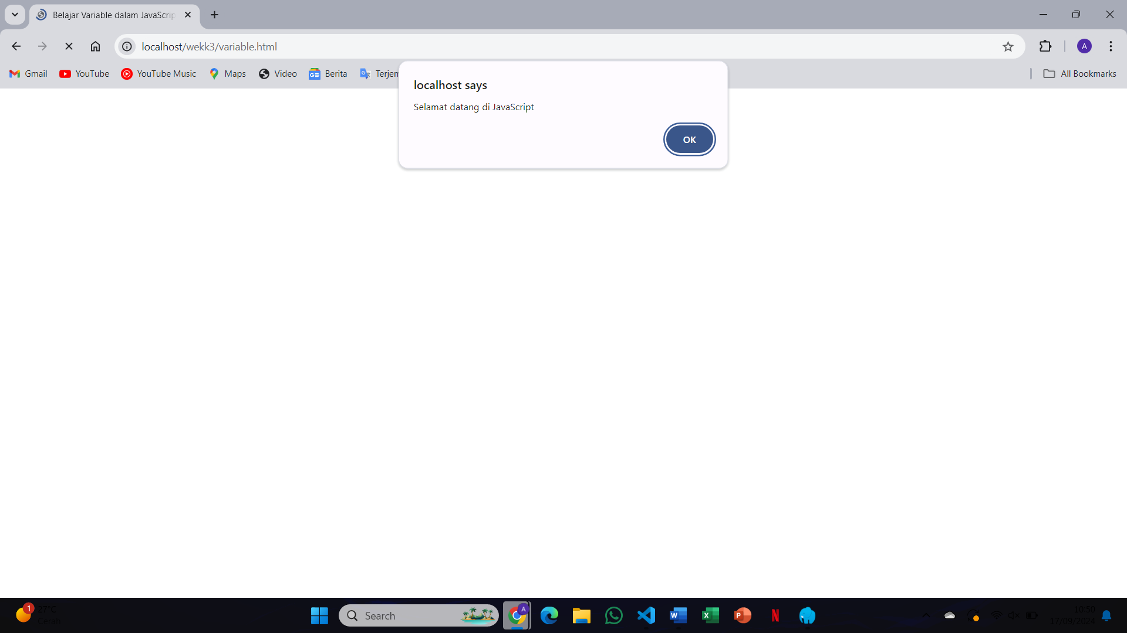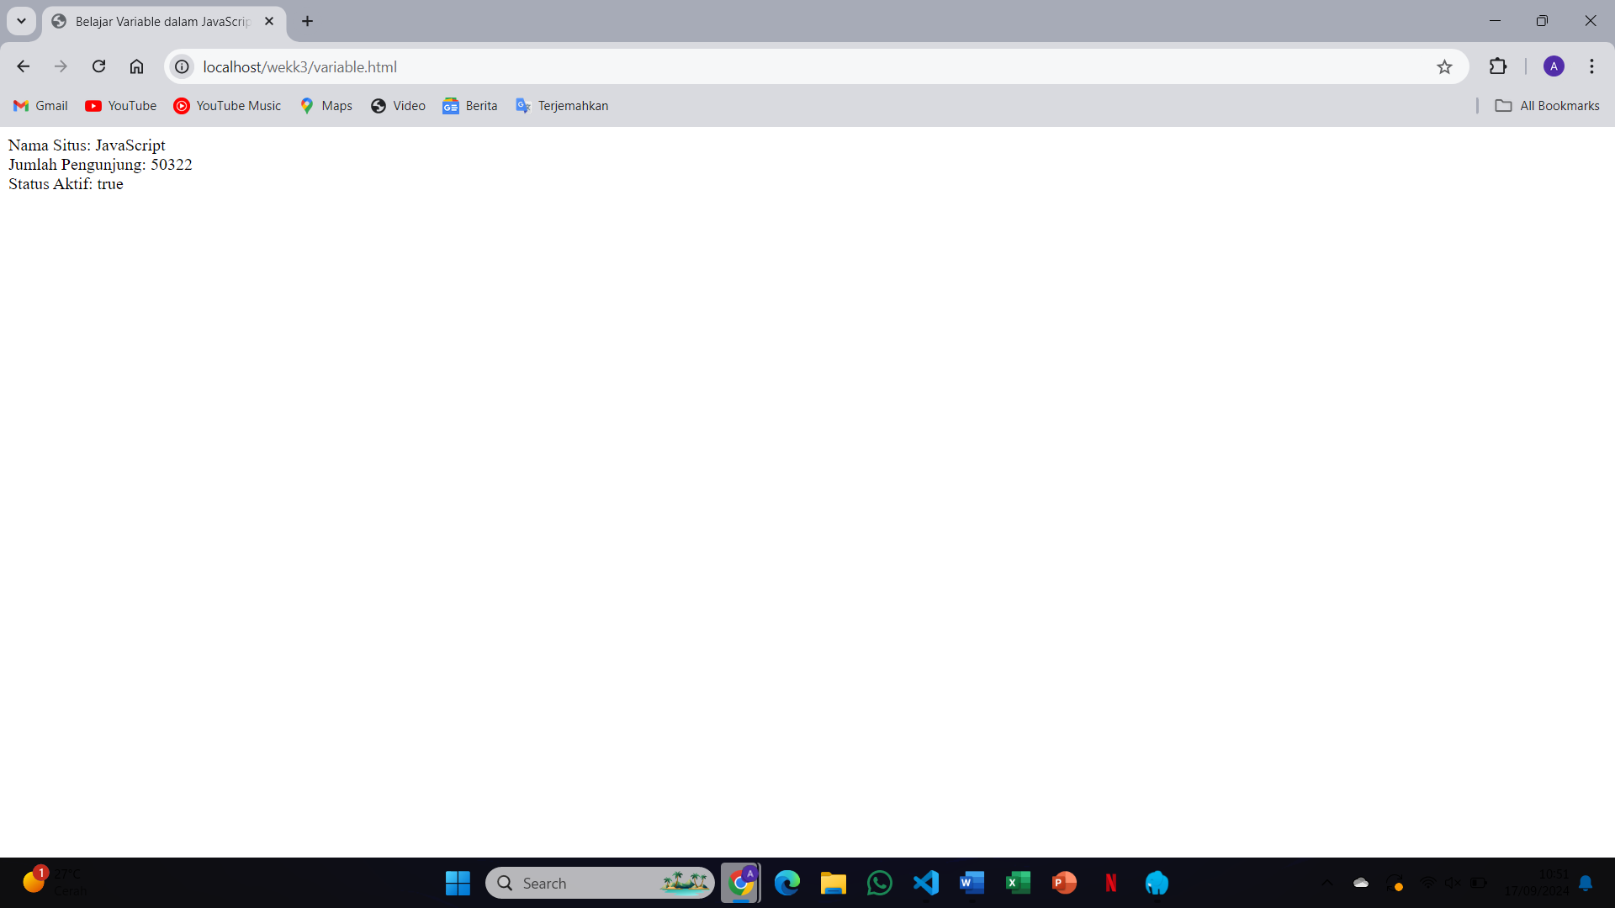The value of the title variable, "Learn Javascript Programming", will be displayed using document.write() in the browser
14. 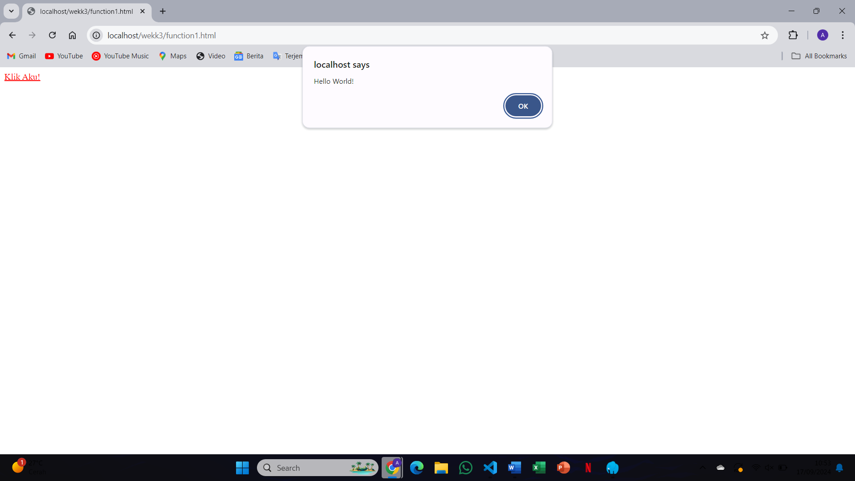The browser displays "Hello from a function" because the function sayHello() is called, which writes this text to the document
15. 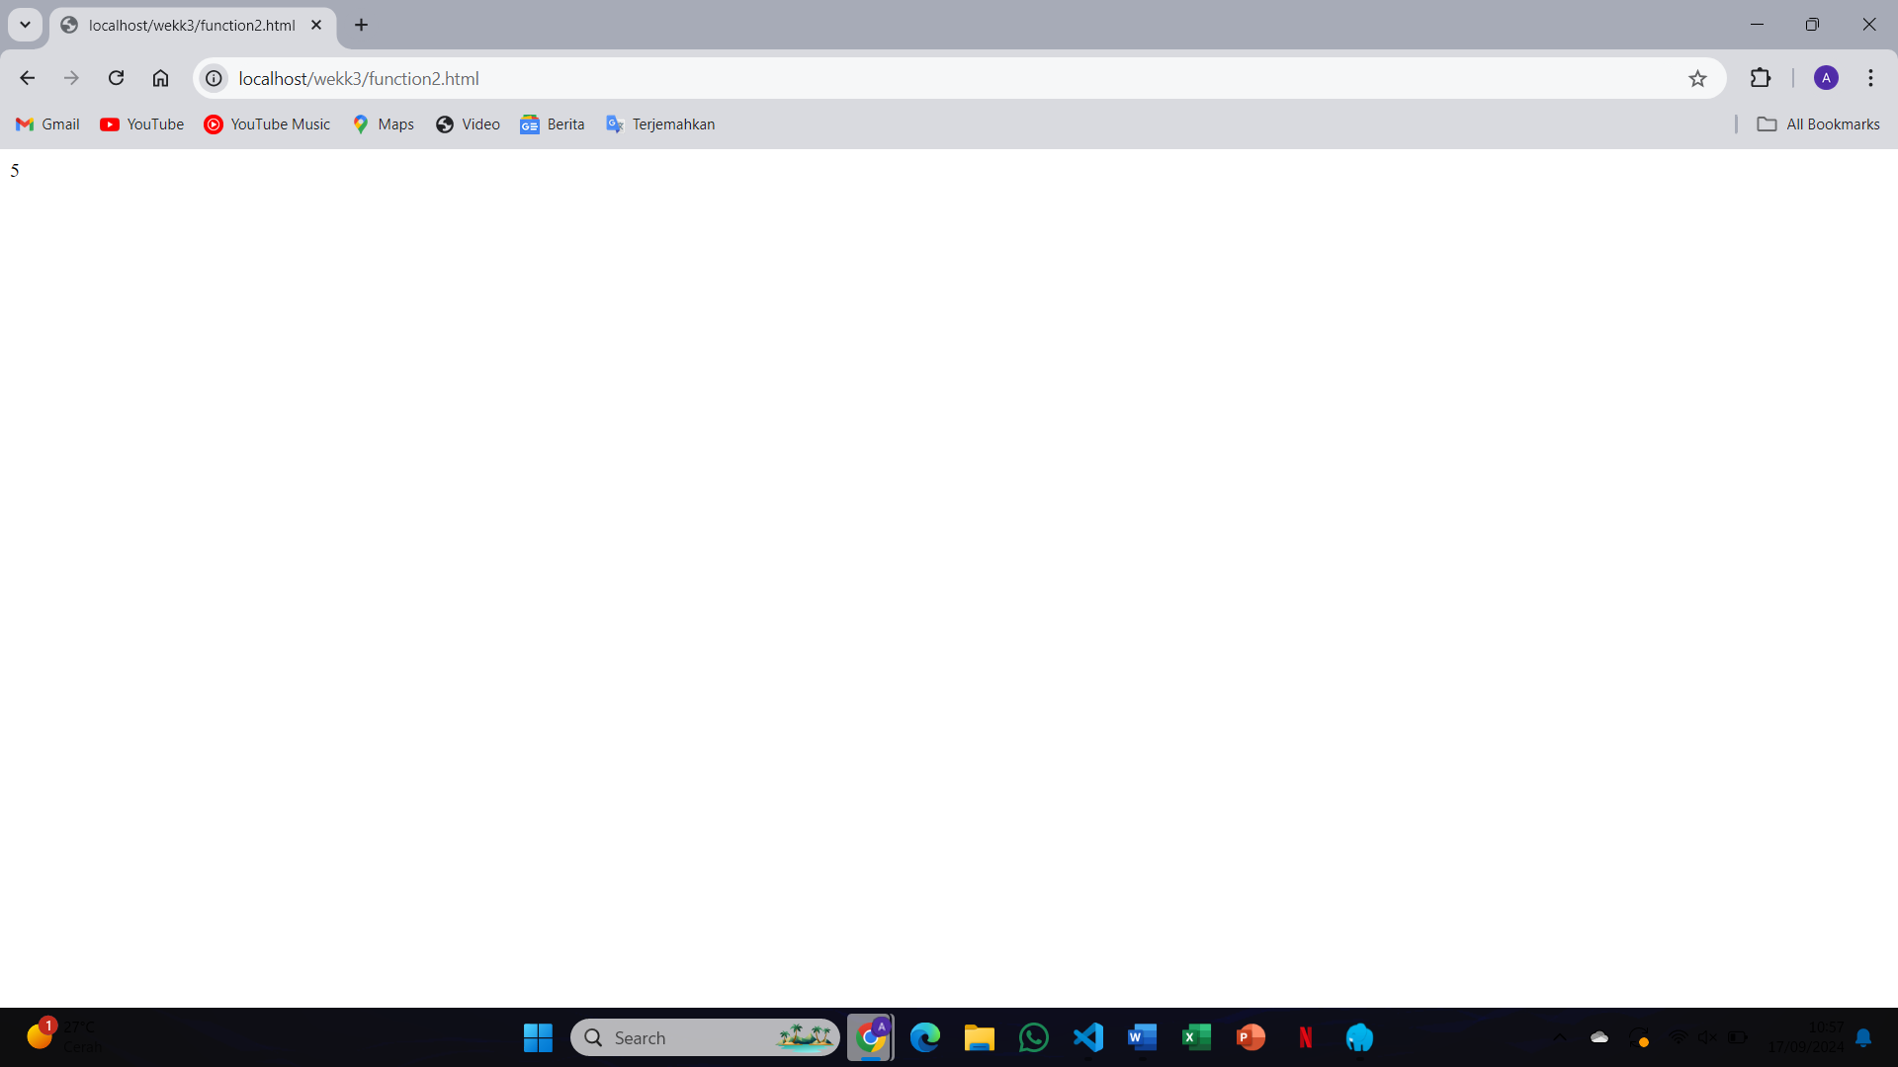The function will display the sum of the two parameters passed to it, such as addNumbers(2,3) resulting in "5"
16. 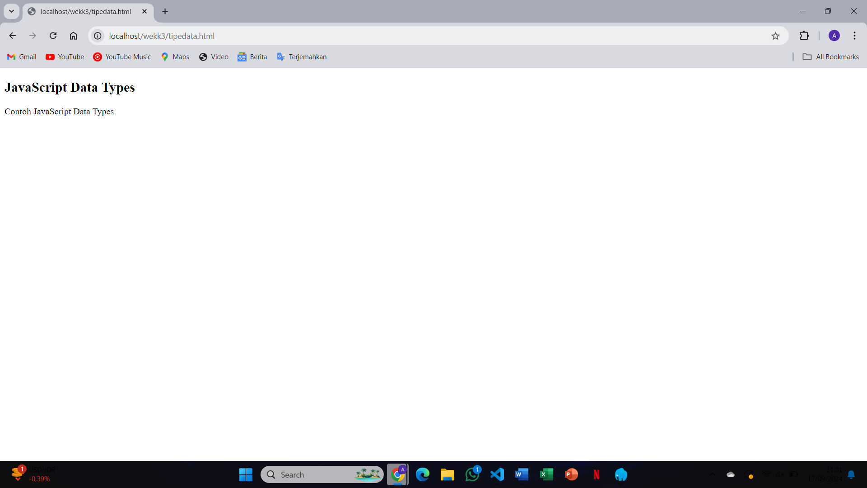The browser will display examples of different data types, such as strings and numbers, written with document.write()
17. 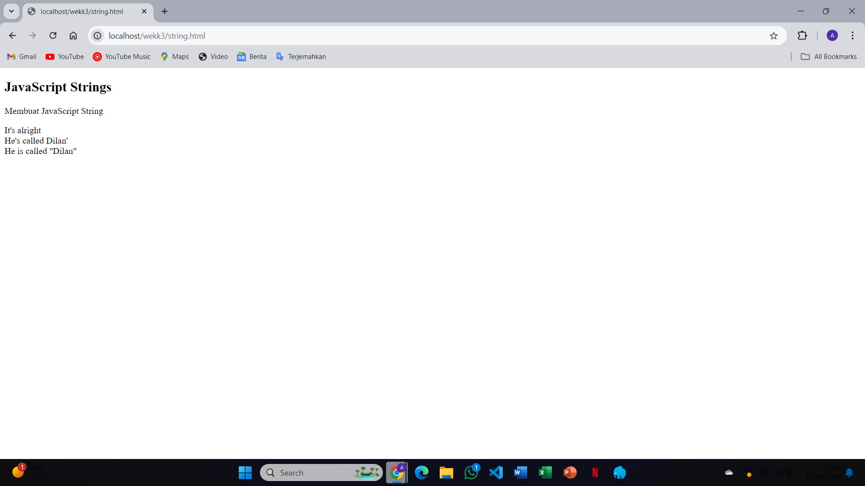The string "This is a string" will be displayed, demonstrating how JavaScript handles string data types
18. 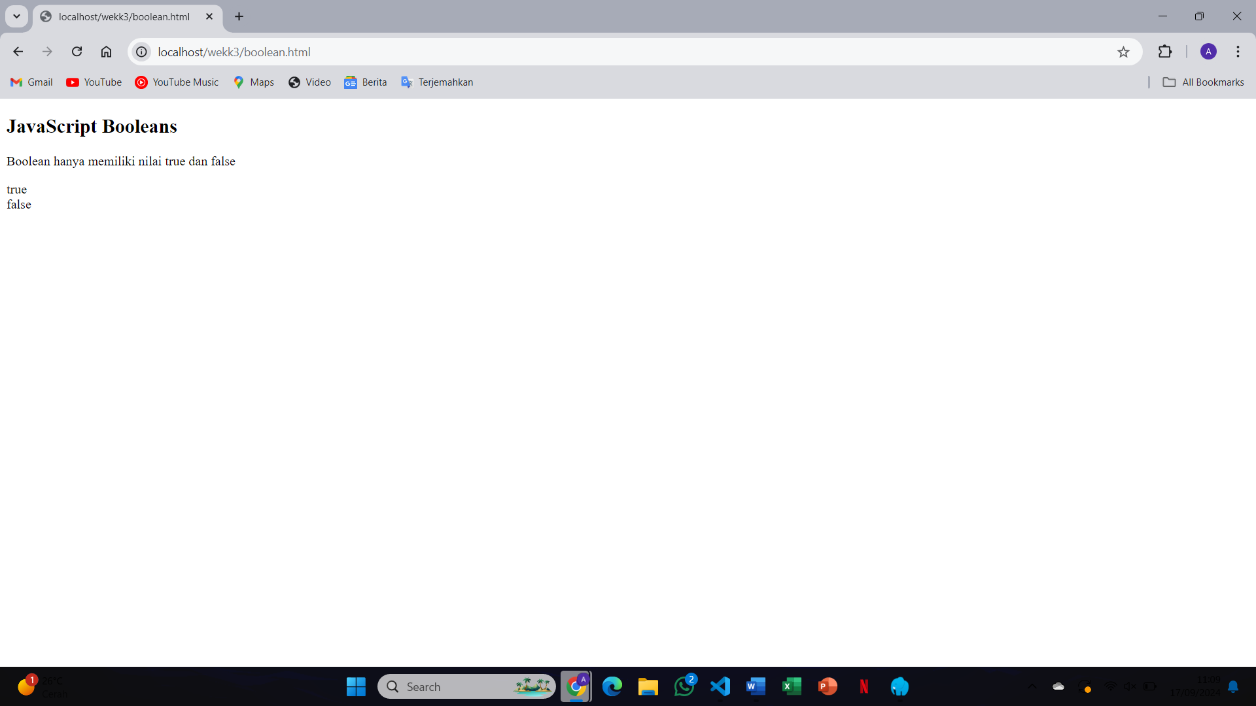A Boolean value (true or false) will be displayed based on the conditions coded in the file
19. 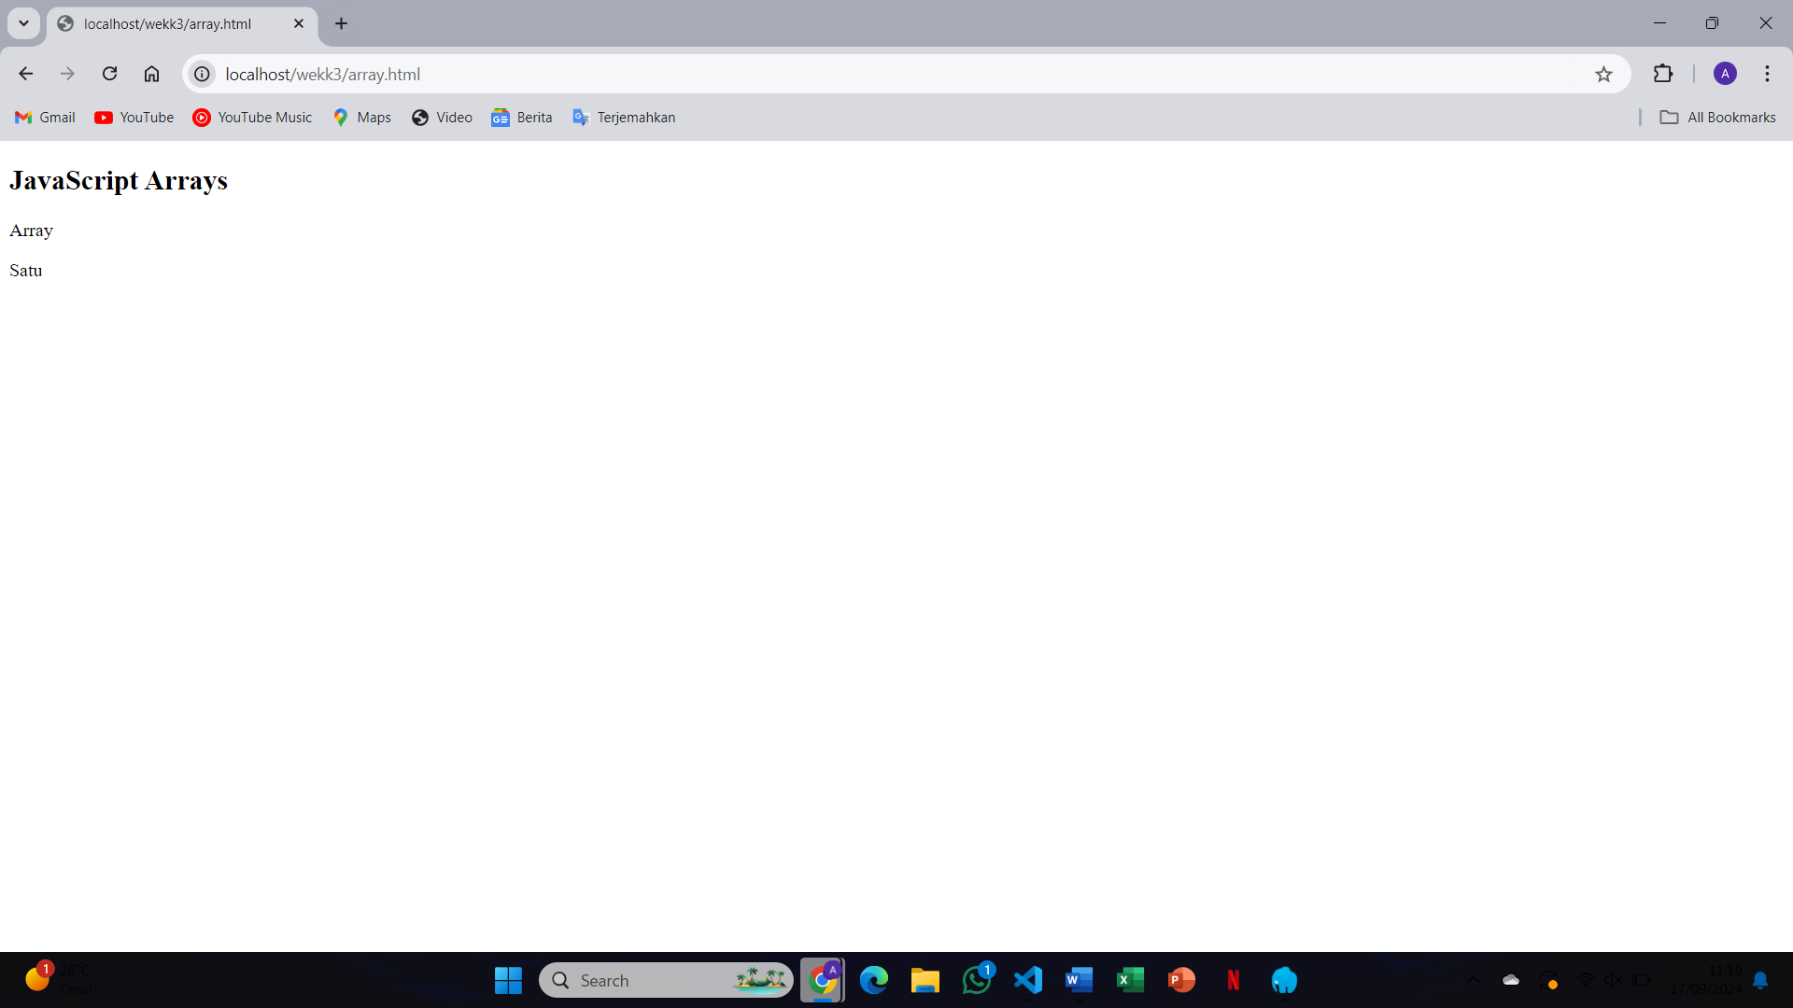The array values will be displayed in the browser, showcasing how arrays work in JavaScript
20. 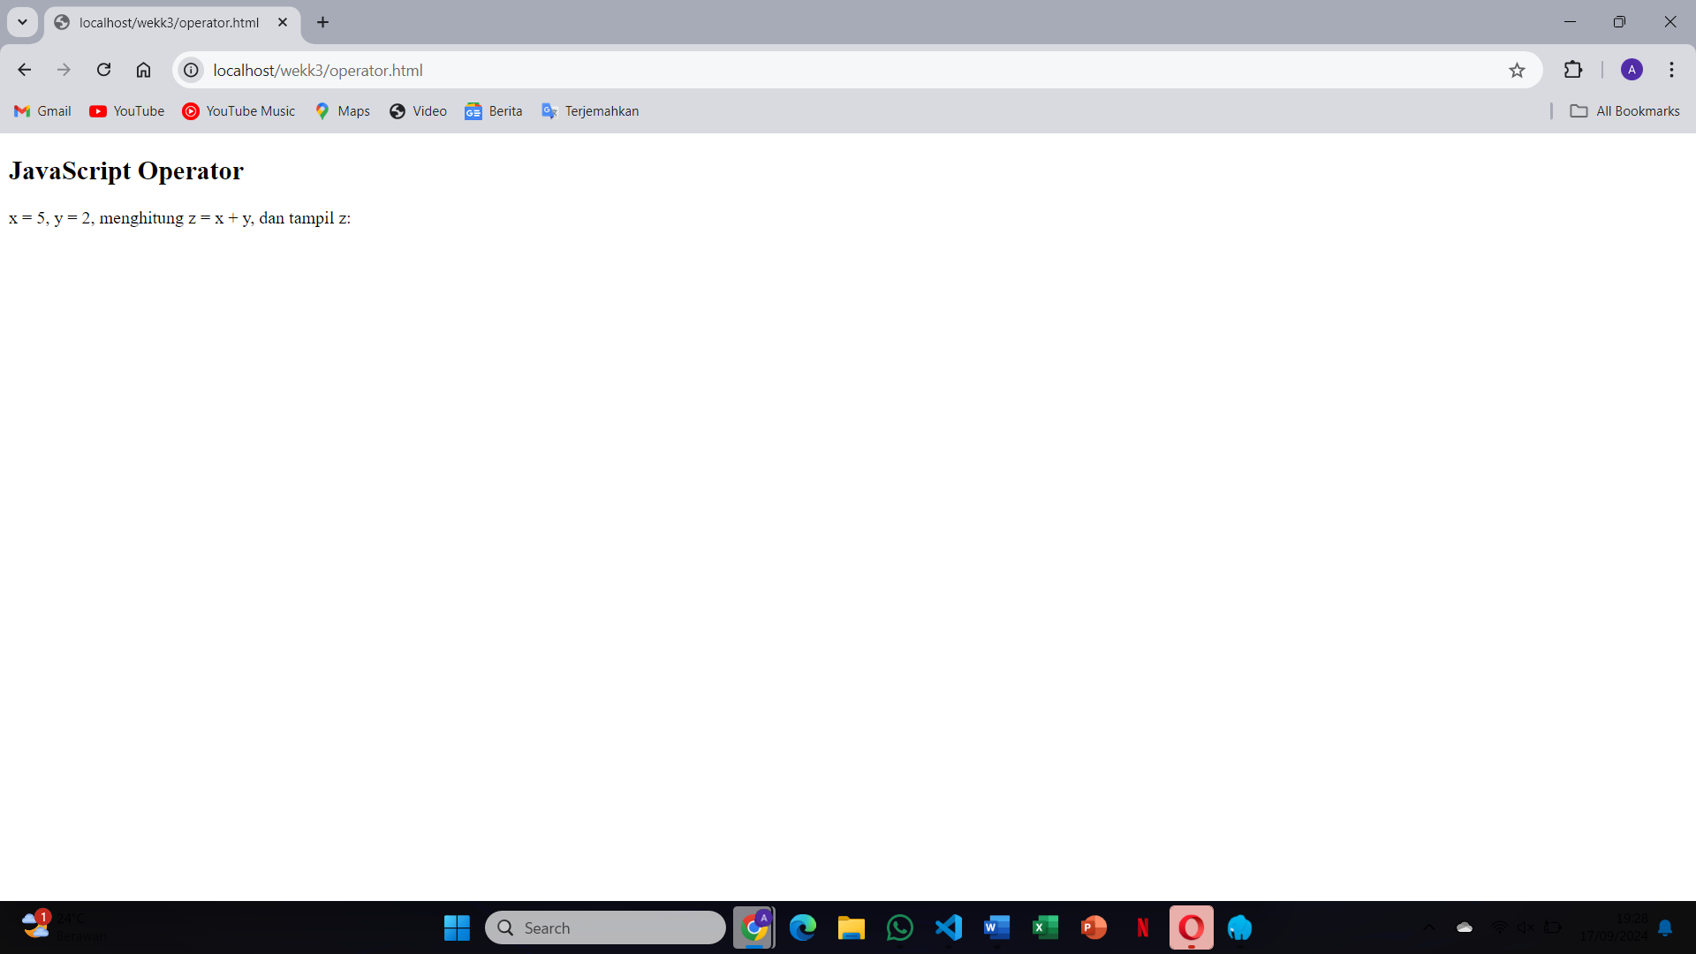Arithmetic operations, such as addition and multiplication, will be performed, and the results will be displayed in the browser
21. 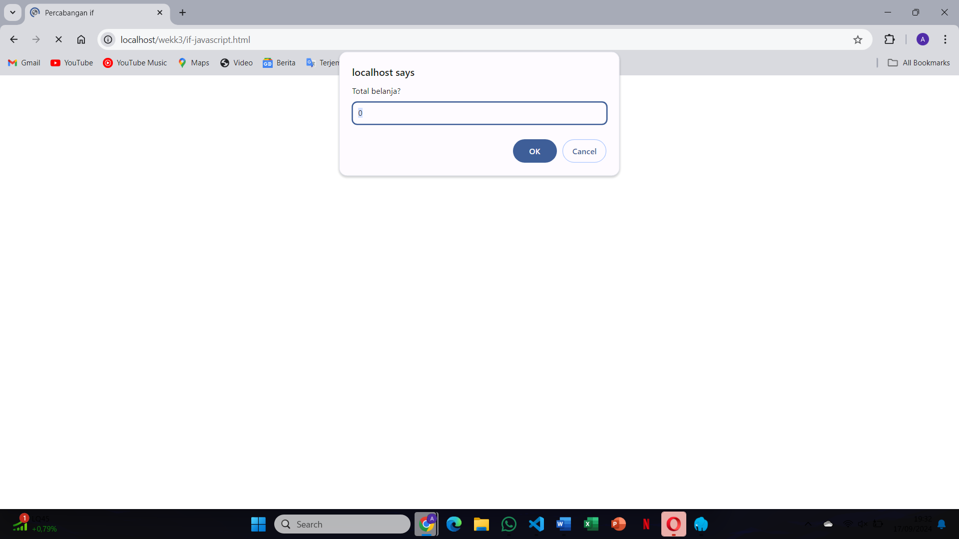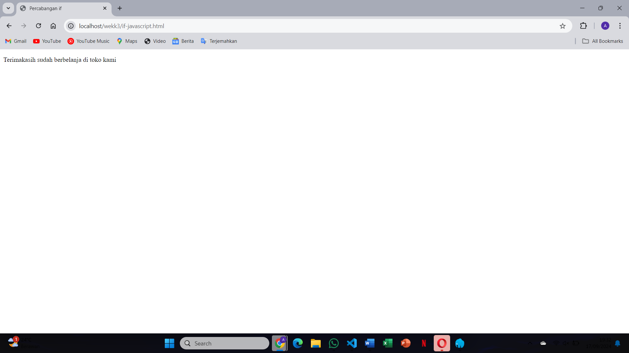The browser will display a message based on the condition in the if statement. If the condition is true, it will display the specified message
22. 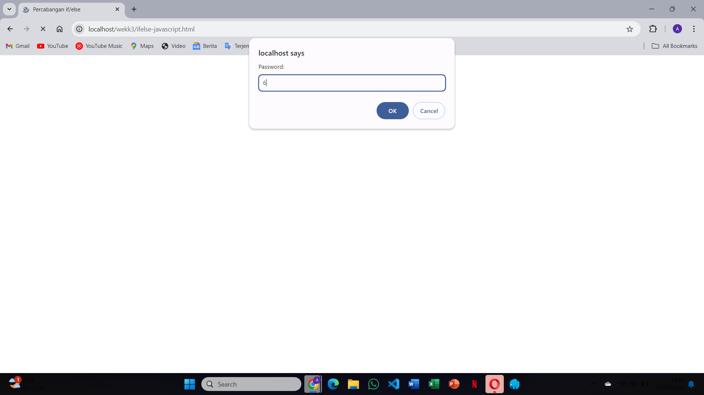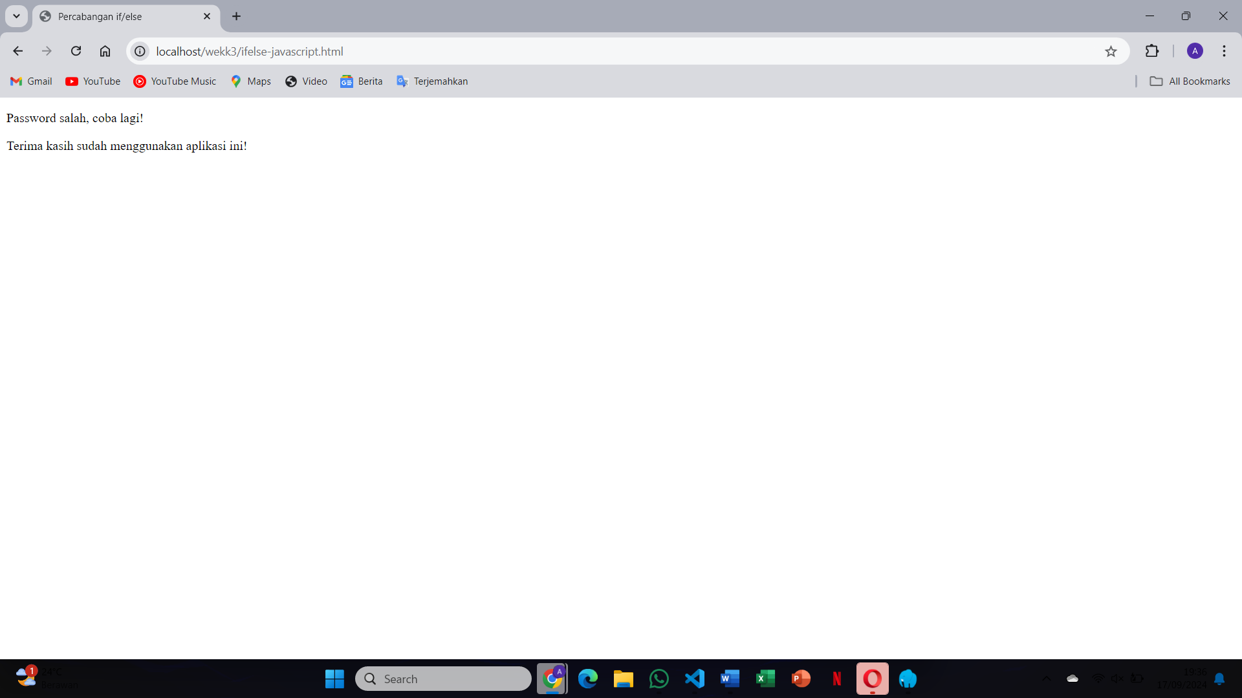he browser will display one of two possible messages depending on whether the condition is true or false
23. 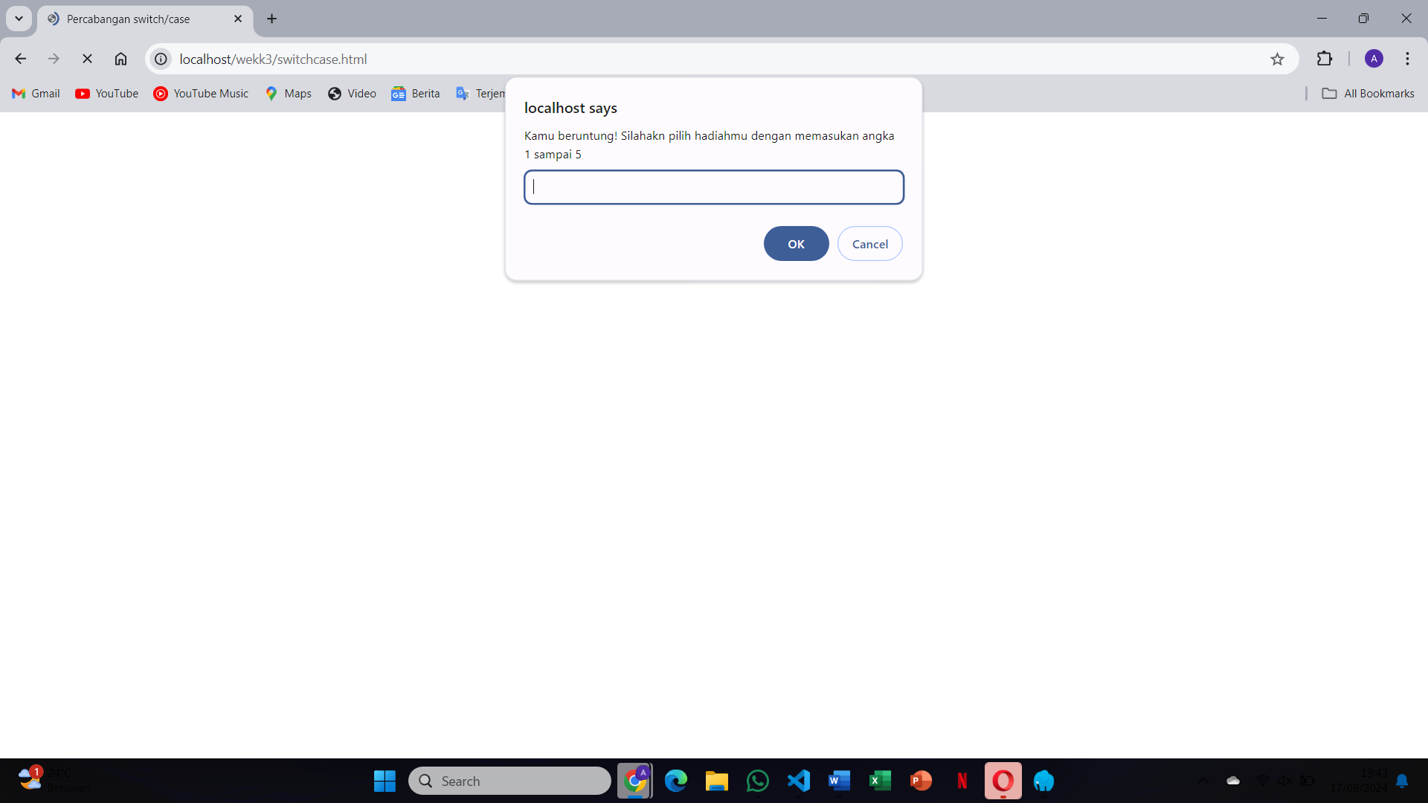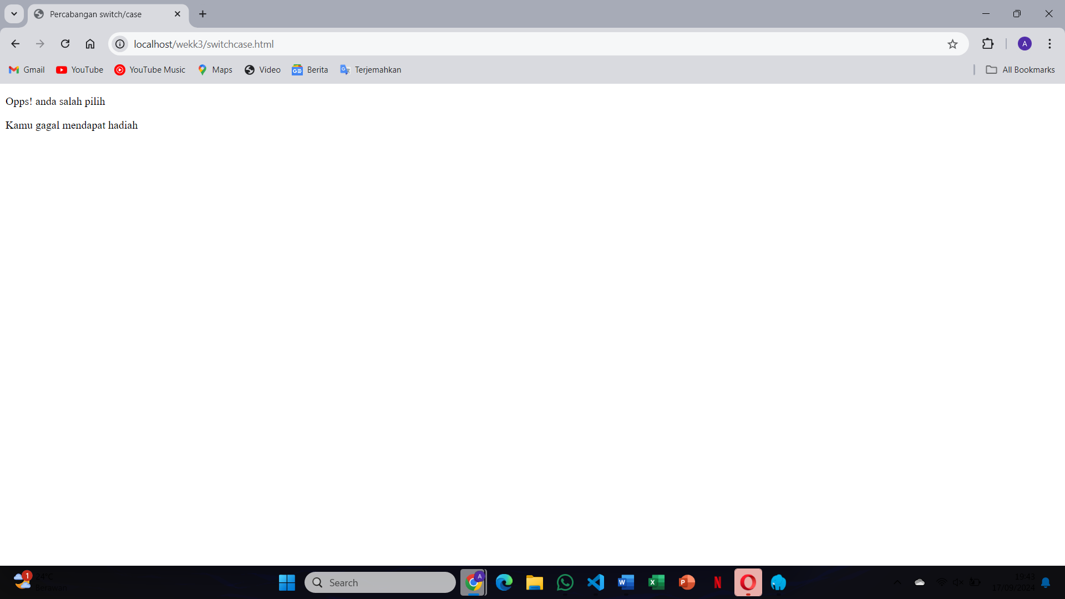 A message based on the matching case in the switch statement will be displayed
24. 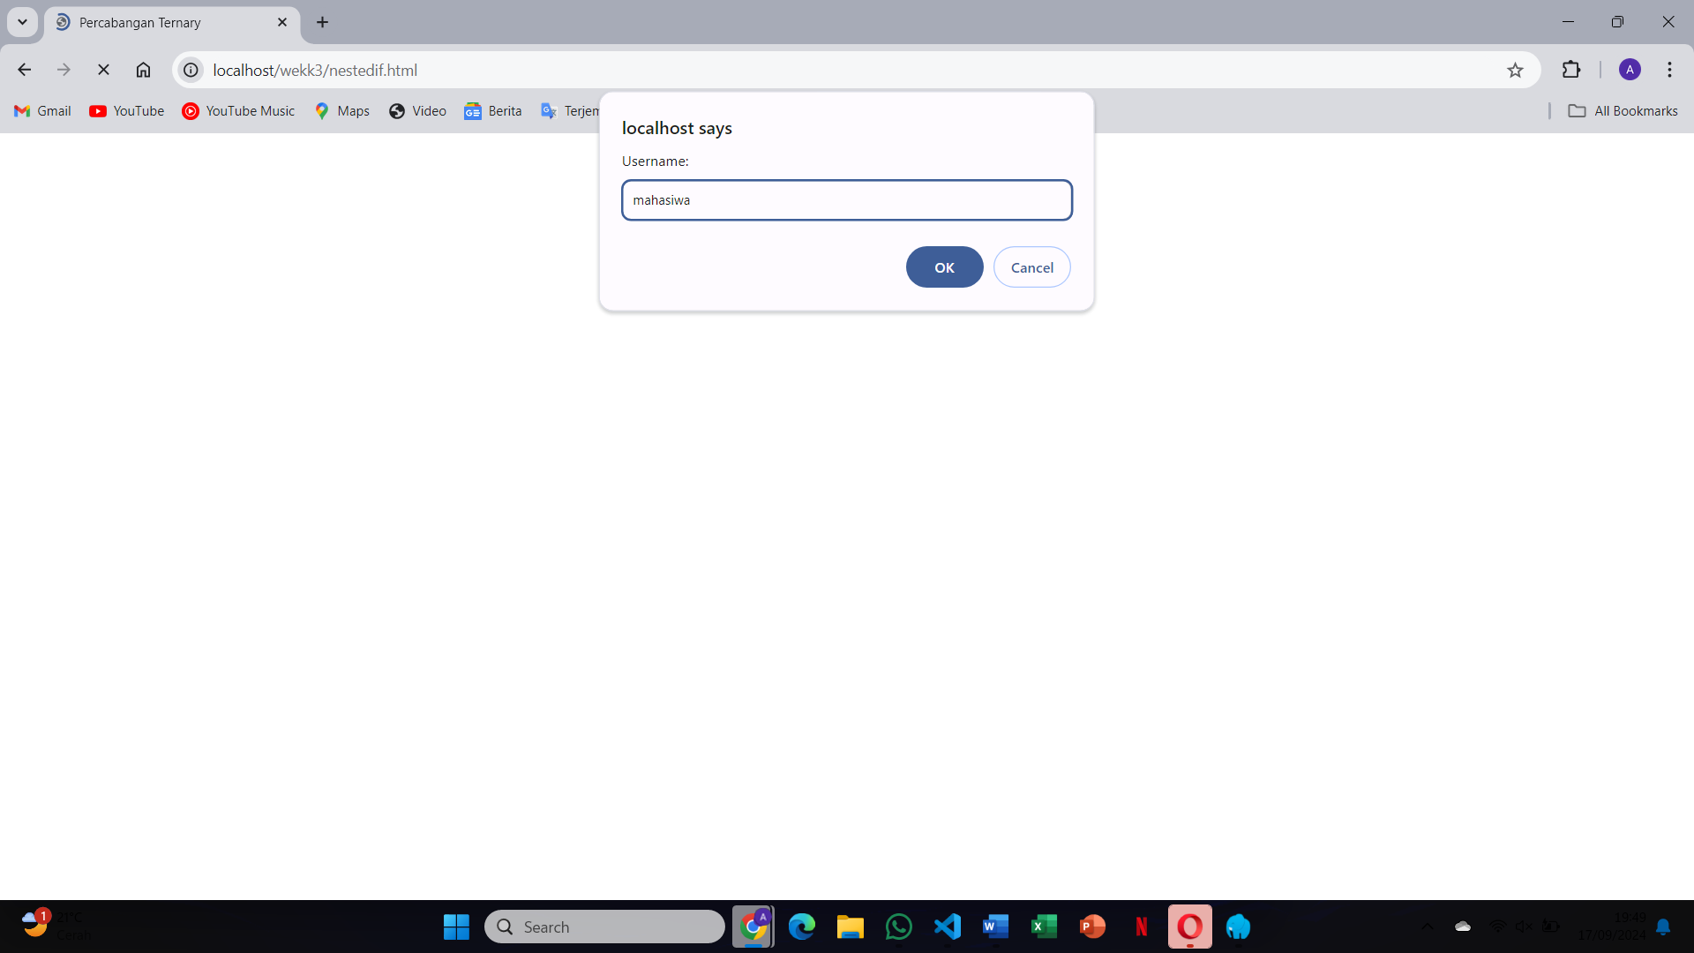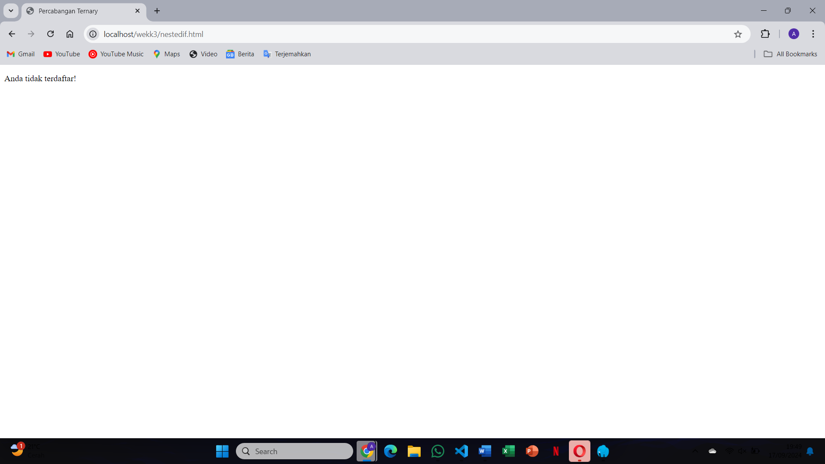The browser will display messages based on the outcome of multiple conditions checked by nested if statements
25. 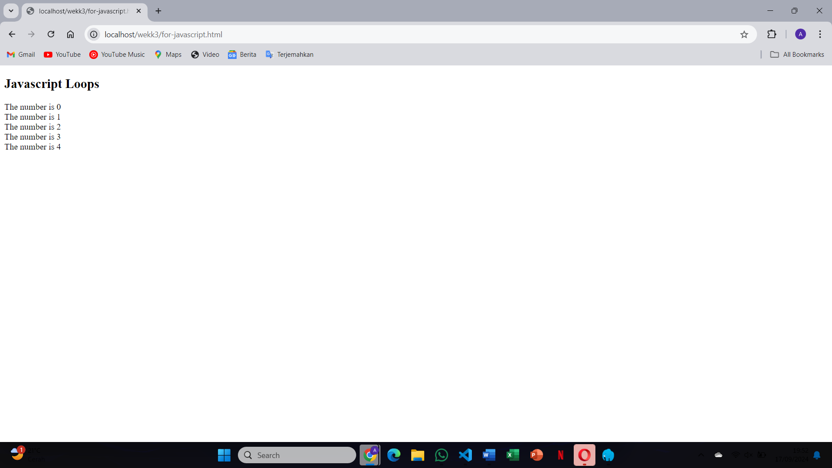he browser will display the output of a loop running a specified number of times, as controlled by the for loop
26. 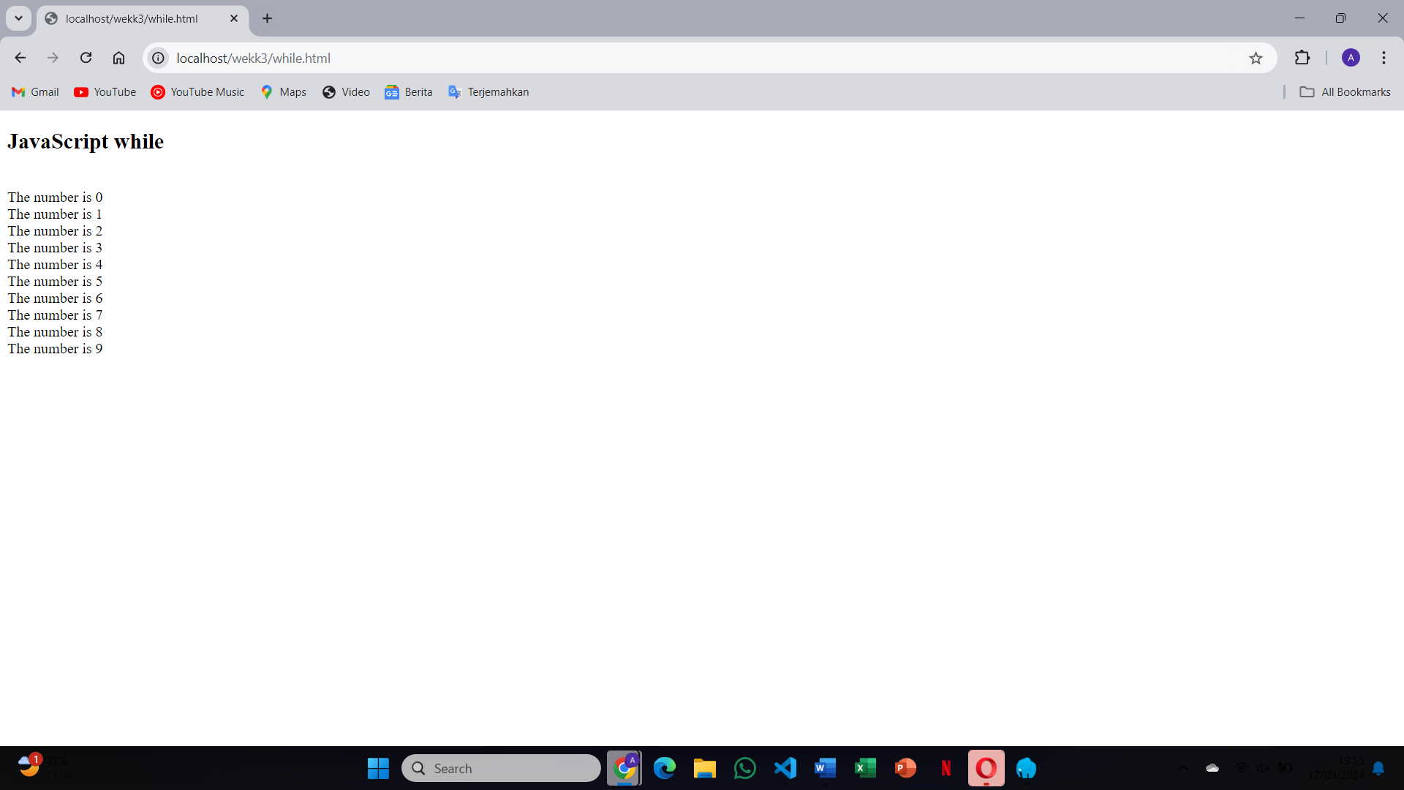 The browser will display output based on the while loop's condition. The loop will continue until the condition becomes false
27. 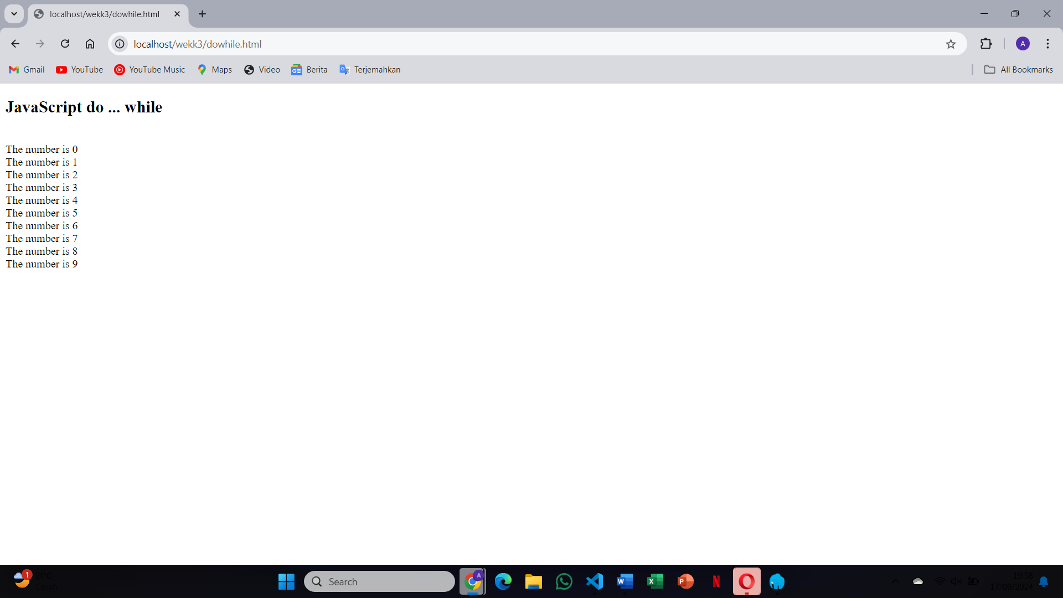The do-while loop will execute the block of code at least once, and the output will be displayed regardless of the condition

<https://github.com/adzinbrillian/DASPRO_WEB_SMT3/tree/main/wekk3>